5.8 Graphing Absolute Value Functions

Objective 1: _________________________________________________________________________________ ___________________________________________________________________________________________

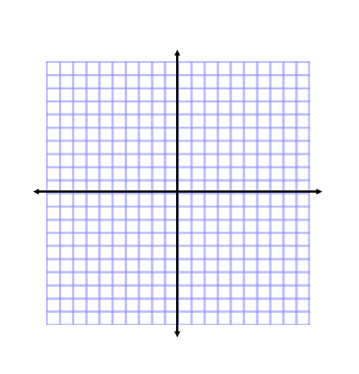
- An absolute value function has a ___________________________ graph.
- The parent function for the family of absolute value functions is $y= \left|x\right|$
- Use a table to values to graph $y= \left|x\right|$. Make sure to include enough points to obtain the correct shape.

Objective 2: _________________________________________________________________________________ ___________________________________________________________________________________________

- A translation is a ______________ of a graph horizontally, vertically, or both. The result is a graph of the same size and shape, but in a different ___________________________.
- You can quickly graph absolute value equations by shifting the graph of $y= \left|x\right|$.
- The graph of $y= \left|x\right|+k$ is a ______________ shift of $y= \left|x\right|$ $k$ units up or down.
- The graph of $y= \left|x-h\right|$ is a ________________ shift of $y= \left|x\right|$ $h$ units right or left.
Example: Graph the absolute value function $y= \left|x\right|+2$

Example: Graph the absolute value function $y= \left|x+5\right|.$

Example: Graph the absolute value function $y= \left|x-5\right|$

Example: Graph the absolute value function $y= \left|x+2\right|-1$. Describe the translation of the parent function.

