Chapter 5 Practice Test (Sections 6, 7, 8)
- Determine whether the lines are parallel, perpendicular, or neither.
  - $y=3x+2$ b. $x-4y=12$
$18x+6y=7$ $4x+y= -1$

- Write an equation in slope-intercept form of the line that passes through the given point and is parallel to the graph of the given equation. (2 points each)
  - $\left(2, -1\right);y=5x-2$

  - $\left(0, -5\right);y=9x$

- Write an equation in slope-intercept form of the line that passes through the given point and is perpendicular to the graph of the given equation. (2 points each)
  - $\left(3, 5\right); y= -3x+7$

  - $\left(4, 10\right);y=8x-1$

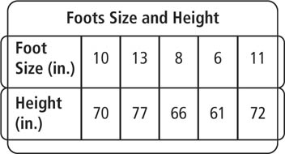
- Use the data in the table to the right.
  - Make a scatterplot of the data. (1 point)

  - Write an equation of a reasonable trend line. Show your work. (3 points)

  - Describe the type of correlation the scatter plot shows. Then, tell whether the correlation reflects a causal relationship. Explain your reasoning. (2 points)

  - Estimate the height of a person whose foot size is 7 inches. Did you use interpolation or extrapolation? Explain. (2 points)

  - Predict the height of a person whose foot size is 14 inches. Did you use interpolation or extrapolation? Explain. (2 points)

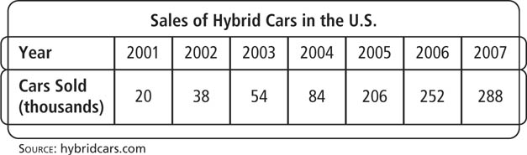
- Use a graphing calculator to create a scatter plot and find an equation of the line of best fit. (2 points)

- Graph each absolute value function by translating $y= \left|x\right|$.
  - $y= \left|x\right|+4$

  - $y= \left|x-2\right|$

  - $y= \left|x+4\right|-2$

