Chapter 6 Review
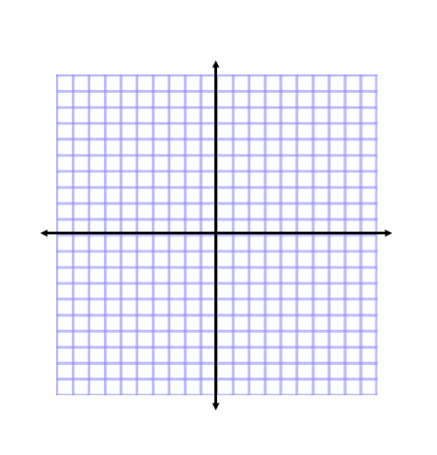
- Solve the system by graphing. Write your answer as an ordered pair. (2 points)
$$2x-y= -5$$
$$x= -3$$

- Solve the system using substitution. Write your answer as an ordered pair. (2 points)
$$4x=3y-2$$
$$18=3x+y$$

- Solve the following systems using elimination. Write your answer as an ordered pair. (2 points each)
  - $3x-2y=1$
$8x+3y=2$

- Write a system of equations to model each situation. Solve the system using the method of your choice. (4 points each)
  - Average movie prices in the United States are, in general, lower than in other countries. It would cost $80.09 to buy three tickets in Japan plus two tickets in Switzerland. Three tickets in Switzerland plus two tickets in Japan would cost $75.61. How much does an average movie ticket cost in each of these countries?

  - Your school’s talent show will feature 10 solo acts and 2 ensemble acts. The show will last 80 minutes. The 5 solo performers judged best will give a repeat performance at a second 55 minute show, which will also feature the 2 ensemble acts. Each solo act lasts x minutes, and each ensemble act lasts y minutes. How long is each solo act and each ensemble act?

  - A metalworker has a metal alloy that is 20% copper and another alloy that is 65% copper. How many kilograms of each alloy should the metalworker combine to create 90 kg of a 47% copper alloy?

  - A hotel offers two activity packages. One costs $192 and includes 3 hours or horseback riding and 2 hours of parasailing. The second costs $213 and includes 2 hours of horseback riding and 3 hours of parasailing. What is the cost for 1 hour of each activity?

- Tell whether the systems have one solution, infinitely many solutions, or no solution. (1 point each)
  - $-3x+6y=10$
$$-3x+6y= -4$$

- Solve the system of inequalities by graphing. (2 points)
$$x> -3$$
$$-3x+y ≥6$$

- Graph any inequality. Switch with someone and write an inequality to represent your partner’s graph.

- A farmer plans to create a rectangular garden that he will enclose with chicken wire. The garden can be no more than 30 ft wide. The farmer would like to use at most 180 ft of chicken wire. What are the possible lengths and widths of the garden? Write a system of linear inequalities that models this situation. Graph the system to show all possible solutions.

- You have 60 megabytes of space left on your portable media player. You can choose to download song files that use 3.5 MB or video files that use 8 MB. You want to download at least 12 files. Write a system of inequalities to model this situation. What is a graph showing the numbers of song and video files you can download?

