Chapter 7 Practice Test
- Graph the functions by hand. State the domain, range, and vertex of each function. Show your work.
  - $f\left(x\right)= -2{\left(x-3\right)}^{2}+5$ b. $f\left(x\right)=2x^{2}+4x-1$
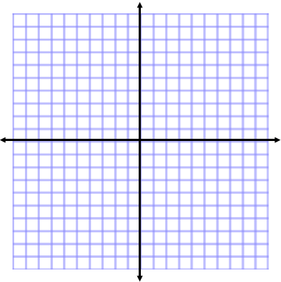

Domain: all real numbers Domain: all real numbers

Range: $y ≤5$ Range: $y ≥ -3$

Vertex: $(3, 5)$ Vertex: $(-1, -3)$

- Use the discriminant to determine the number and type of solutions of the equation $3x^{2}-5x+4=0$. Show your work.
2 imaginary solutions

- Solve the following quadratic equations using the square root property.
  - $-2{\left(y+3\right)}^{2}+1= 9$ b. $3x^{2}-11=3$
$y= -3 ±2i$ $x= ± \frac{\sqrt{42}}{3}$

- Solve the following quadratic equations using by completing the square.
  - $x^{2}+8x-9=0$ b. $2p^{2}+8p-3=0$
$x=1 or x=-9$ $p=\frac{4 ± \sqrt{22}}{2}$

- Solve the following quadratic equations using the quadratic formula.
  - $\frac{2}{3}x^{2}-\frac{5}{6}x=\frac{1}{3}$ b. $3x\left(3x-2\right)= -2$
$$x=\frac{5 ± \sqrt{57}}{8}$$
$x=\frac{1+i}{3}$

- Find an equation of the parabola that contains the points $\left(1, 4\right), \left(2, 7\right), and (4, 25)$. Do this algebraically and show your work.
$$y=2x^{2}-3x+5$$

- A baseball is hit by a batter. The height (in feet) $h(t)$ of the ball after $t$ seconds is given by:
$$h\left(t\right)= -16t^{2}+100t+4$$

  - What was the height of the ball when the batter made contact?
$$4 feet$$

  - What was the maximum height of the ball?

$$160.25 feet$$

  - When did the ball reach the maximum height?
$$3.125 seconds$$

- The numbers of households that own recreational vehicles (RVs) are shown in the table for various years. Let $f(t)$ be the number (in millions) of households that own recreational vehicles at $t$ years since 1980.
  - Use a quadratic regression to find the equation that will model the data well. Round to four decimal places for your a, b, and c values.
$$f\left(t\right)=0.0085t^{2}- .16t+6.48$$

  - Use the equation to predict the number of households that will own RVs in 2016. Show your work.
$$\sim 12 households$$

  - Use the equation to predict the year(s) in which 20 million households will (or did) own RVs. Show your work.
$$2030$$
- A ski club charters a bus that normally costs $300 per person. A group discount reduces the fare by $6 for each ticket sold; the more tickets sold, the lower the per-person fare. There are 31 seats on the bus, including 1 seat for the driver.
  - What size of a group would maximize the bus company’s revenue?
$$25 people to maximize the revenue$$

  - What would the maximum revenue be?
$$Maximum revenue is \$3, 750$$

- A rancher plans to use 500 feet of fencing and a side of his barn to form a rectangular boundary for cattle. What dimensions of the rectangle would give the maximum area? What is that area?
$$Dimensions=125 x 250 feet$$
$$Maximum area=31, 250 ft^{2}$$

- Find the x-intercepts.
  - $h\left(x\right)=3x^{2}+2x-2$ b. $k\left(x\right)= -5x^{2}+3x-1$
$$\left(\frac{-1 ± \sqrt{7}}{3}, 0\right) \left(\frac{-3 ±i\sqrt{11}}{-10}, 0\right) or no x-intercepts$$

