9.1 Simplifying Radical Expressions

Objective 1: _________________________________________________________________________________

- A radical expression is an expression that contains a _____________________________.
  - Examples of radical expressions:

- To convert between exponential and radical form:

  - Example:

Example: If the expression is in exponential form, write it in radical form. If it is in radical form, write it in exponential form.
- $x^{\frac{3}{7}}$ c. ${\left(3w+1\right)}^{\frac{4}{5}}$

- $\sqrt{x^{5}}$ d. $\sqrt[8]{{\left(2x+5\right)}^{3}}$

Example: Write the expression in exponential form and then simplify the result.
- $\sqrt[3]{x^{3}}$ c. $\sqrt[3]{x^{21}}$

- $\sqrt[3]{x^{12}}$

Objective 2: _________________________________________________________________________________

Objective 3: _________________________________________________________________________________
- Product Property for Radicals: _________________________________________________________

- To simplify a radical expression:
  - ______________________________________________________________________________
  - ______________________________________________________________________________
  - ______________________________________________________________________________
  - ______________________________________________________________________________
Example: Simplify the radical expressions.
- $\sqrt{200}$ d. $\sqrt{48x^{4}y^{13}}$

- $\sqrt{x^{7}}$ e. $\sqrt{{\left(5x+3\right)}^{9}}$

- $\sqrt{12w^{11}}$

Example: Simplify the radical expressions.
- $\sqrt[3]{40x^{17}}$ c. $\sqrt[5]{{\left(2x+7\right)}^{34}}$

- $\sqrt[4]{80x^{20}y^{15}}$

Example: Simplify the radical expressions.
- $\sqrt[12]{{\left(3x+7\right)}^{8}}$ c. $\sqrt[4]{81x^{6}}$

- $\sqrt[10]{4}$ d. $\sqrt[3]{\sqrt{6}}$

Objective 4: _________________________________________________________________________________
- A radical function is a function whose equation contains a _____________________________________________________________________________________
  - Examples of radical functions:
- A square root function is a radical function in which any radicals are _____________________________
  - Examples of square root functions:
- A radical model is a radical function, or its graph, that describes an ______________________________
- A square root model is a square root function, or its graph, that describes an __________________________________________________
Example: Graph the square root function $f\left(x\right)= \sqrt{x}$ by creating a table of values.
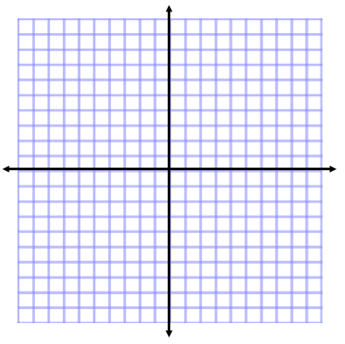

Objective 5: _________________________________________________________________________________ ___________________________________________________________________________________________

Example: The percentages of foundations that compensate all of their board members are shown in a table for various assets on page 507. Let $f(a)$ be the percentage of foundations with assets of $a$ million dollars that compensate all of their board members. A model of the situation is $f\left(a\right)=1.5\sqrt{a}+4$.
- Use a graphing calculator to draw the graph of $f$ and, in the same viewing window, the scattergram of the data. Does the graph of $f$ fit the data well?

- Estimate the percentage of foundations with assets of $30 million that compensate all of their board members.

9.2 Adding, Subtracting, and Multiplying Radical Expressions

Objective 1: _________________________________________________________________________________

- Radicals that have the same _____________________ and the same __________________________ are called _________________________________.
  - Example:
- To add or subtract like radicals, ___________________________________________________________. Also referred to as _________________________________ like radicals.
  - Example:

Example: Combine like radicals.
- $3\sqrt{x}+6\sqrt{x}$ c. $4\sqrt[3]{x}+5\sqrt[6]{x}$

- $4\sqrt[5]{3xy^{2}}- 2\sqrt[5]{3xy^{2}}$ d. $3\sqrt[4]{x}-2\sqrt[4]{x+1}$

Example: Perform the indicated operations.
- $3\sqrt[4]{x}+4\sqrt{x}+2\sqrt[4]{x}+7\sqrt{x}$

- $3\left(5\sqrt[3]{x+1}-2\right)-4\sqrt[3]{x+1}$

Example: Perform the indicated operation.
- $\sqrt{45w}+\sqrt{20w}$ c. $2\sqrt[3]{16x^{4}}-4x\sqrt[3]{54x}$

- $5b\sqrt{3a^{3}}-a\sqrt{12ab^{2}}$

- To multiply radical expressions, use the ______________________________________. Then, check to see if the product can be __________________________.
  - Example:

Example: Find the product.
- $2\sqrt{6x}·5\sqrt{2x}$

- $3\sqrt{5x}\left(4\sqrt{x}-\sqrt{5}\right)$

Objective 2: _________________________________________________________________________________

- Power property of radicals: _____________________________________________________________
  - Example:

Example: Simplify.
- $(2\sqrt{x}-7)(3\sqrt{x}+4)$

- $(2\sqrt{3x}+5)(2\sqrt{3x}-5)$

Example: Find the product.
- $\left(2\sqrt[5]{x^{2}}\right)\left(7\sqrt[5]{x^{4}}\right)$

- $(\sqrt[4]{x^{3}}+5)(\sqrt[4]{x^{3}}-6)$

- To multiply radicals with different indexes, _________________________________________________.
  - Example:

Example: Perform the operations.
- $2\sqrt{x}(\sqrt[3]{x}-5)$

- ${\left(\sqrt[3]{x}+3\sqrt[5]{x^{2}}\right)}^{2}$

Objective 3: _________________________________________________________________________________ ___________________________________________________________________________________________

Example: Simplify.
- ${\left(x-\sqrt{3}\right)}^{2}$

- ${\left(\sqrt{a}+3\sqrt{b}\right)}^{2}$

9.3 Rationalizing Denominators and Simplifying Quotients of Radical Expressions

Objective 1: _________________________________________________________________________________ ___________________________________________________________________________________________

Objective 2: _________________________________________________________________________________

- To rationalize the denominator, ___________________________________________________________ _____________________________________________________________________________________
  - Example: $\frac{4}{5\sqrt{3x}}$

- To rationalize the denominator for indexes other than 2, ______________________________________ _____________________________________________________________________________________
Example: Simplify.
- $\frac{1}{\sqrt[3]{x}}$

- $\frac{3y}{\sqrt[5]{\left(8x^{2}\right)}}$

- To rationalize an expression with a binomial in the denominator, use the _________________________
  - Example:

Example: Simplify.
- $\frac{5}{3+\sqrt{x}}$

- $\frac{\sqrt{x}+4}{3\sqrt{x}-\sqrt{2}}$

- $\frac{\sqrt{a}+\sqrt{b}}{\sqrt{a}-\sqrt{b}}$

Objective 3: _________________________________________________________________________________

- The quotient property: __________________________________________________________________
  - Example:
Example: Simplify.
- $\sqrt{\frac{5}{k}}$

- $\sqrt[3]{\frac{7y}{2x^{2}}}$
9.4 Graphing and Combining Square Root Functions

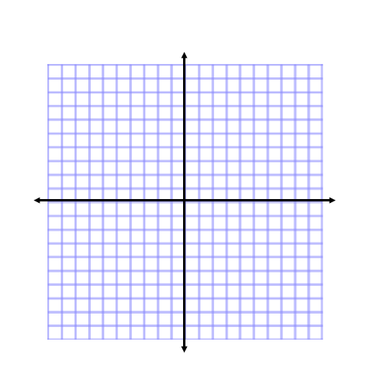
Objective 1: _________________________________________________________________________________ ___________________________________________________________________________________________

Graph the function $f\left(x\right)=\sqrt{x}$ by completing the table.
x | y
0
1
4
9

Now graph the function $f\left(x\right)= \sqrt{x+2}$by completing the table.
x | y
-2
-1
2
7

Now graph the function $f\left(x\right)=\sqrt{x}+1$ by completing the table.
x | y
0
1
4
9

On the same coordinate plane, graph the functions $f\left(x\right)=\sqrt{x}, g\left(x\right)=2\sqrt{x}, h\left(x\right)=\frac{1}{2}\sqrt{x}, and j\left(x\right)= -\sqrt{x}.$

- For functions of the form $f\left(x\right)=a\sqrt{x-h}+k$, what observations can you make about $a, h,$ and $k$?
  - $a:$

  - $h$:

  - $k$:

- To sketch the graph of $f\left(x\right)=a\sqrt{x-h}+k$:
  - ______________________________________________________________________________
  - ______________________________________________________________________________
  - ______________________________________________________________________________

Objective 2: _________________________________________________________________________________ ___________________________________________________________________________________________

Example: Graph the following square root functions. Identify the domain and range.
- $g\left(x\right)= -2\sqrt{x+4}-1$

- $f\left(x\right)=2\sqrt{x-3}+5$

Objective 3: _________________________________________________________________________________ ___________________________________________________________________________________________

Example: Let $f\left(x\right)=2\sqrt{x}-3$ and $g\left(x\right)=5\sqrt{x}+4$. For each of the following functions, find an equation of the function.
- $f+g$

- $f-g$

- $f ·g$

- $\frac{f}{g}$

9.5 Solving Radical Equations

Objective 1: _________________________________________________________________________________

- A radical equation in one variable is an equation in one variable that contains _____________________ _____________________________________________________________________________________
  - Example:

- When solving radical equations, you must check for __________________________________________
- To solve a square root equation:
  - ______________________________________________________________________________
  - ______________________________________________________________________________
  - ______________________________________________________________________________
Example: Solve the equation. Check for extraneous solutions.
- $2\sqrt{x}+5=13$

- $x=\sqrt{x-1}+3$

- $2\sqrt{x-3}-\sqrt{x}=0$

- $\sqrt{t-5}-\sqrt{t}= -1$

- $\sqrt{2x+1}-\sqrt{x+2}=1$

- $\sqrt[3]{\left(2w-4\right)}+7=9$

- Graphing both sides of an equation can also be used to solve a square root function.
  - ______________________________________________________________________________
  - ______________________________________________________________________________
Example: Use graphing to solve the square root function.
- $\sqrt{x+8}=x^{2}-3x-4$

Objective 2: _________________________________________________________________________________ ___________________________________________________________________________________________

- To find the x-intercepts of a function, ______________________________________________________ _____________________________________________
Example: Find the x-intercepts of the graph of $f\left(x\right)=\sqrt{3x-4}-\sqrt{x+2}$.

Objective 3: _________________________________________________________________________________ ___________________________________________________________________________________________

Example: In example 10 of Section 9.1, we worked with the model $f\left(a\right)=1.5\sqrt{a}+4$, where $f(a)$ is the percentage of foundations with assets of $a$ million dollars that compensate all of their board members. Estimate the assets of foundations of which 25% of the foundations compensate all of their board members.

9.6 Modeling with Square Root Functions

Objective 1: _________________________________________________________________________________ ___________________________________________________________________________________________

- To find an equation of a square root curve that contains two given points.
  - ____________________________________________________________________________________________________________________________________________________________
  - ______________________________________________________________________________
  - ______________________________________________________________________________
Example: Find an equation of a square root curve that contains the given points.
- $\left(2, 3\right) and (5, 7)$

- $\left(4, 5\right) and (9, 8)$

Example: Find an equation of a square root curve that contains the given points.
- $\left(0, 5\right) and (6, 19)$

- $\left(0, 3\right) and (1, 2)$

Objective 2: _________________________________________________________________________________

Year | Number of Arrests
2001 | 114
2002 | 207
2003 | 283
2004 | 326
2005 | 364
Example: The numbers of US Coast Guard drug arrests are shown in the table for various years. Let $f\left(t\right)$ be the number of US Coast Guard drug arrests in the year that is $t$ years since 2000.
- Find an equation of $f$.

- Now, compare your equation with the regression equation from your calculator.

- Let $n=f(t)$. Find the $n$-intercept. What does it mean in this situation?

- Predict the number of U.S. Coast Guard drug arrests in 2018.

- Predict in which year there will be 900 U.S. Coast Guard drug arrests.

