Geometry Name: __________________________________________
Final Exam STUDY GUIDE

The exam is worth 20% of your final grade. On the exam, you will be permitted to use one 3” by 5” note card with your notes on it. The notes on the notecard must be hand written by you in your own handwriting.
On the exam, show your work whenever possible and circle your answer as appropriate.
- Find the value of y.

- Find the value of the variable in each parallelogram.
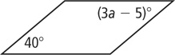
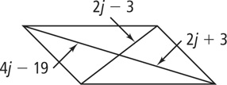
- b)

- Determine whether the parallelogram is a rectangle, rhombus, or square.
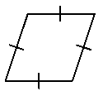
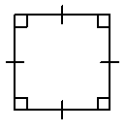
- b) c)

- Find the value of the missing angles of the kite.

- Find the value of the missing variables of the isosceles trapezoid.

- Determine whether the polygons are similar. If so, write a similarity statement and give the scale factor.

- Given: RM || SN; RM ⊥ MS; SN ⊥ NT
Prove: ΔRSM ~ ΔSTN

- Solve for each variable.
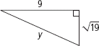
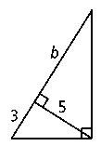
- b)

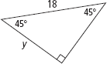
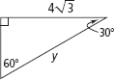
c) d)

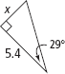
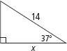
e) f)

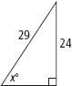
g) h)

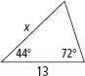
i)

- Find the area of each figure below. Round to the nearest tenth if needed.
- b)

c) d)

e) f)

g) h)

- In part a, find the circumference. In part b, find the arc length.
- b)

- Find the surface area and volume of the following figures.
- b)

c) d)

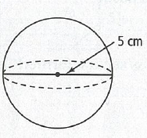
e)

