Algebra 1 Name: __________________________________________
Semester 2 STUDY GUIDE

The exam is worth 20% of your final grade. On the exam, you will be permitted to use one 3” by 5” note card with your notes on it. The notes on the notecard must be hand written by you in your own handwriting.
On the exam, show your work whenever possible and circle your answer as appropriate.
- Chapter 5 (Sections 6-8) – Linear Functions
  - Write an equation in slope-intercept form of the line that passes through the given point and is parallel to the graph of the given equation.
    - $\left(2, -2\right);y= -x-2$ ii. $\left(2, -1\right);y=-\frac{3}{2}x+6$

  - Write an equation in slope-intercept form of the line that passes through the given point and is perpendicular to the graph of the given equation.
    - $\left(0, 0\right);y=-3x+2$ ii. $\left(-2, 3\right);y=\frac{1}{2}x-1$

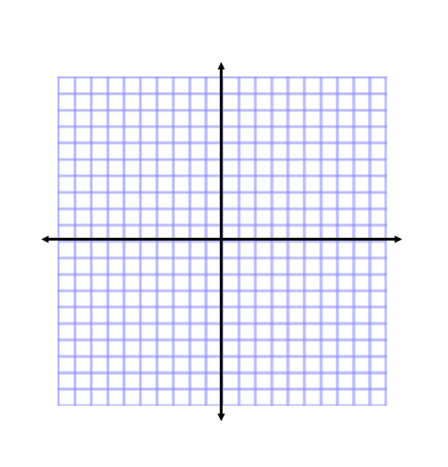
  - Graph the absolute value function $y= \left|x+1\right|-1$.

  - Use the data in the table to the right.
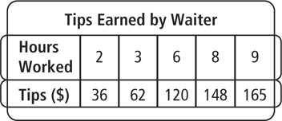
    - Make a scatterplot of the data.

    - Write an equation of a reasonable trend line by hand. Show your work.

    - Use a graphing calculator to find an equation of the line of best fit.

    - Describe the type of correlation the scatter plot shows. Then, tell whether the correlation reflects a causal relationship. Explain your reasoning.

    - Estimate the amount of tips earned when the waiter worked 7 hours. Did you use interpolation or extrapolation?

    - Predict the amount of tips earned if the waiter worked 10 hours. Did you use interpolation or extrapolation?

- Chapter 6 – Systems of Equations and Inequalities
  - Solve the system by graphing. Write your answer as an ordered pair.
    - $\begin{aligned}y=\frac{1}{2}x+7 \\ y=\frac{3}{2}x+3\end{aligned}$ ii. $\begin{aligned}y=x-4 \\ y=-x\end{aligned}$

  - Solve the system using substitution. Write your answer as an ordered pair.
    - $\begin{aligned}3x+2y=23 \\ \frac{1}{2}x-4=y\end{aligned}$ ii. $\begin{aligned}2=2y-x \\ 23=5y-4x\end{aligned}$

  - Solve the system using elimination. Write your answer as an ordered pair.
    - $\begin{aligned}3x+y=5 \\ 2x-2y=-2\end{aligned}$ ii. $\begin{aligned}5x-9y=-43 \\ 3x+8y=68\end{aligned}$

  - Write a system of equations to model each situation. Solve the system using the method of your choice.
    - A coin bank has 250 coins, dimes and quarters, worth $39.25. How many of each type of coin are there?

    - A plane leaves Chicago and flies 750 miles to New York. If it takes 2.5 hours to get to New York flying against the wind, but only 2 hours to fly back to Chicago, what is the plane’s rate of speed and what is the wind speed?

  - Solve the systems of inequalities by graphing.
    - $\begin{aligned}y<2x+4 \\ 2x-y≤4\end{aligned}$ ii. $\begin{aligned}y≤-\frac{1}{3}x+7 \\ y≥-x+1\end{aligned}$

  - Write a system of inequalities to model each situation. Solve the system by graphing.
    - You received a $100 gift certificate to a clothing store. The store sells T-shirts for $15 and dress shirts for $22. You want to spend no more than the amount of the gift certificate. You want to leave at most $10 of the gift certificate unspent. You need at least one dress shirt. What are all of the possible combinations of T-shirts and dress shirts you could buy?

    - Cherries cost $4/lb. Grapes cost $2.50/lb. You can spend no more than $15 on fruit, and you need at least 4 lb in all. What is a graph showing the amount of each fruit you can buy?

- Chapter 7 – Exponents
  - Simplify each expression.
    - ${\left(\frac{94x^{7}y^{-\frac{1}{3}}z^{7}}{16x^{-\frac{3}{4}}y^{2}z^{\frac{2}{3}}}\right)}^{0}$ v. $3x^{\frac{1}{2}}y^{\frac{2}{3}} {\left(4x^{3}y^{2}\right)}^{\frac{1}{2}}$

    - $\frac{3x^{4}y^{-2}}{x^{5}y^{-9}}$ vi. ${3.4}^{2} ·{64}^{\frac{1}{6}}$

    - ${\left(\frac{ab}{4}\right)}^{-3}$ vii. ${\left(81x^{\frac{4}{3}}\right)}^{\frac{1}{2}}$

    - $r^{6}s^{-3}t^{-1} ·r^{3}s^{-4}t$

  - Convert the expressions to radical or exponential form.
    - ${\left(4x\right)}^{\frac{1}{2}}$ ii. $\sqrt[5]{x^{4}}$

  - Graph each exponential function by hand.
    - $y=\frac{1}{2}·2^{x}$ ii. $y=2·{\left(\frac{1}{2}\right)}^{x}$

  - Write an exponential growth or decay function to model each situation and solve.
    - A customer deposits $2000 in a savings account that pays 5.2% interest compounded quarterly. How much money will the customer have in the account after 2 years?

    - A band performs a free concert in a local park. There are 200 people in the crowd at the start of the concert. The number of people in the crowd grows 15% every half hour. How many people are in the crowd after 3 hours? Round to the nearest person.

  - Write a recursive and explicit definition for each geometric sequence.
    - $6561, 2187, 729, 243, …$ ii. $3, 12, 48, 192, …$

- Chapter 8 – Polynomials and Factoring
  - Classify each of the following polynomials by degree and number of terms.
    - $3x^{3}+2$ ii. $x$ iii. $2x^{2}+x-1$

  - Simplify each expression.
    - $\left(4x^{2}+9x+1\right)+\left(2x^{2}+7x+13\right)$

    - $\left(5x^{4}+7x+2\right)-(3x^{2}-2x-9)$

    - $\left(5w+6\right)\left(2w-7\right)$

    - ${\left(y-1\right)}^{2}$

    - $(4w+5)(2w^{2}-3w+1)$

  - Factor each expression completely.
    - $4x^{2}+4x+1$ iv. $6n^{4}+15n^{3}-9n^{2}$

    - $5x^{2}+32x-21$ v. $9v^{4}+12v^{3}-18v^{2}-24v$

    - $x^{2}-7x-18$

