Algebra 2 Name: __________________________________________
Semester 2 STUDY GUIDE

The exam is worth 20% of your final grade. On the exam, you will be permitted to use one 3” by 5” note card with your notes on it. The notes on the notecard must be hand written by you in your own handwriting.
On the exam, show your work whenever possible and circle your answer as appropriate.
- Chapter 6 – Polynomial Functions
  - Let $f\left(x\right)=4x^{2}+5x-9$, $g\left(x\right)=6x^{2}-3x+7$ and $h\left(x\right)=2x-4$.
    - Find $f+g$.

    - Find $f-g$.

    - Find $f·g$.

    - Find $h^{2}$.

  - Factor the following expressions.
    - $5x^{3}+40$

    - $81x^{4}-1$

  - Solve the following equations by factoring.
    - $4x^{2}-8x=32$

    - $9x^{3}-12=4x-27x^{2}$

    - $3r^{2}=6r$

    - $16x^{2}=25$

- Chapter 7 – Quadratic Functions
  - Solve the following equations using the square root property.
    - $3p^{2}-11=3$

    - $5{\left(x-6\right)}^{2}+3=33$

  - Solve the following equations using the quadratic formula.
    - $x^{2}=-2x+5$

    - $2x^{2}=5x+4$

  - Solve the following equations by completing the square.
    - $8x^{2}+4x-3=0$

    - $x^{2}+5x+7=0$

  - Find an equation of the parabola that contains the points $\left(1, 6\right), \left(2, 11\right), and (3, 18)$.

  - The percentages of California’s population who are foreign born and the percentages who were born in other U.S. states are listed in the table for various years.
Year | Percent Foreign Born | Percent Born in other U.S. States
1930 | 18.9 | 47.0
1940 | 13.4 | 50.0
1950 | 10.0 | 53.0
1960 | 8.5 | 51.0
1970 | 8.8 | 47.9
1980 | 15.1 | 39.5
1990 | 21.7 | 31.8
2000 | 25.9 | 23.5
    - Let $f(t)$ and $g\left(t\right)$ be the percentages of California’s population that are foreign born and born in other U.S. states, respectively, at $t$ years since 1900. Find and verify regression equations of $f$ and $g$.

    - Estimate when the percentages of foreign born and those born in other U.S. states were equal. What is that percentage?

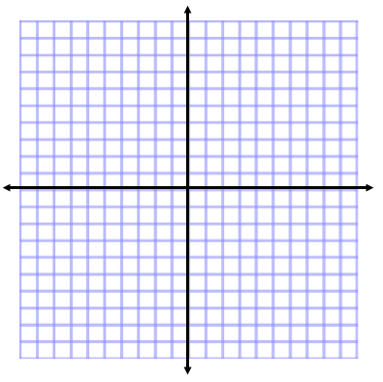
  - Graph each function by hand. Identify the vertex, domain, and range.
    - $y=-2{\left(x-3\right)}^{2}+5$ ii. $y=3x^{2}-12x+7$

- Chapter 8 – Rational Functions
  - Find the domain of the function $f\left(x\right)=\frac{5}{6x^{2}+11x-10}$.

  - Perform the indicated operation.
    - $\frac{5x^{4}}{3x^{2}+6x+12} ·\frac{x^{3}-8}{15x^{7}}$

    - $\frac{p^{2}-4t^{2}}{p^{2}+6pt+9t^{2}} ÷\frac{p^{2}-3pt+2t^{2}}{p^{2}+3pt}$

    - $\frac{5x+12}{-2x^{2}-8x}-\frac{2x+1}{x^{2}+2x-8}$

    - $\frac{x+2}{x^{2}-9}+\frac{3}{x^{2}+11x+24}$

  - Simplify the complex fraction $\frac{\frac{x}{x-4}-\frac{2x}{x+1}}{\frac{x}{x+1}-\frac{2x}{x-4}}$.

  - Solve the equation.
    - $\frac{2}{x-1}-\frac{5}{x+1}=\frac{4x}{x^{2}-1}$

    - $\frac{5}{x-3}=\frac{x}{x-2}+\frac{x}{x^{2}-5x+6}$

- Chapter 9 – Radical Functions
  - Simplify.
    - $\sqrt{24x^{5}y^{10}}$

    - $\sqrt[3]{\left(24x^{10}y^{24}\right)}$

    - $\sqrt[5]{{\left(6x+11\right)}^{27}}$

    - $\frac{4\sqrt[3]{x}}{6\sqrt[5]{x}}$

    - $\frac{\sqrt{x}+1}{2\sqrt{x}-3}$

    - $4\sqrt{12x^{3}}-2x\sqrt{75x}+\sqrt{3x^{3}}$

    - $\left(2+4\sqrt{x}\right)\left(3-5\sqrt{x}\right)$

  - Solve the following equations.
    - $2\sqrt{x}+3=13$

    - $3\sqrt{5x-4}=27$

    - $3-2\sqrt{x}+\sqrt{9-x}=0$

  - The median heights of boys in the U.S. are listed in the table for various ages, up to 5 years. Let $h=f(t)$ be the median height (in inches) of boys who are $t$ months of age.
Age (months) | Height (inches)
0 | 20.5
6 | 27.0
12 | 30.8
18 | 32.9
24 | 35.0
36 | 37.5
48 | 40.8
60 | 43.4
    - Find an equation of $f$.

    - Estimate the median height of boys who are 6 years old.

    - Estimate the age at which the median height of boys is 3 feet.

