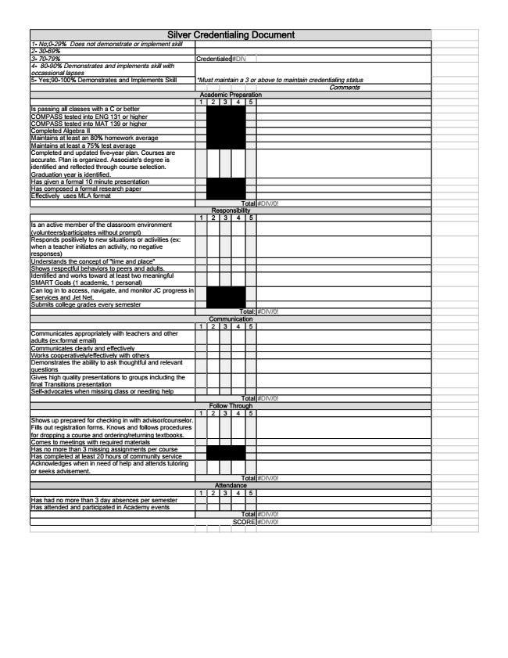

Silver Credentialing Document 1- No;0-29% Does not demonstrate or implement skill 2- 30-69% 3- 70-79% Credentialed#DIV/0! 4- 80-90% Demonstrates and implements skill with occassional lapses *Must maintain a 3 or above to maintain credentialing status 5- Yes;90-100% Demonstrates and Implements Skill
Comments Academic Preparation 1 2 3 4 5 Is passing all classes with a C or better COMPASS tested into ENG 131 or higher COMPASS tested into MAT 139 or higher Completed Algebra II Maintains at least an 80% homework average Maintains at least a 75% test average Completed and updated five-year plan. Courses are accurate. Plan is organized. Associate's degree is identified and reflected through course selection. Graduation year is identified. Has given a formal 10 minute presentation Has composed a formal research paper Effectively uses MLA format
Total #DIV/0! Responsibility 1 2 3 4 5 Is an active member of the classroom environment (volunteers/participates without prompt) Responds positively to new situations or activities (ex: when a teacher initiates an activity, no negative responses) Understands the concept of "time and place" Shows respectful behaviors to peers and adults. Identified and works toward at least two meaningful SMART Goals (1 academic, 1 personal) Can log in to access, navigate, and monitor JC progress in Eservices and Jet Net. Submits college grades every semester
Total: #DIV/0! Communication 1 2 3 4 5 Communicates appropriately with teachers and other adults (ex:formal email) Communicates clearly and effectively Works cooperatively/effectively with others Demonstrates the ability to ask thoughtful and relevant questions Gives high quality presentations to groups including the final Transitions presentation Self-advocates when missing class or needing help
Total #DIV/0! Follow Through 1 2 3 4 5 Shows up prepared for checking in with advisor/counselor. Fills out registration forms. Knows and follows procedures for dropping a course and ordering/returning textbooks. Comes to meetings with required materials Has no more than 3 missing assignments per course Has completed at least 20 hours of community service Acknowledges when in need of help and attends tutoring or seeks advisement.
Total #DIV/0! Attendance 1 2 3 4 5 Has had no more than 3 day absences per semester Has attended and participated in Academy events
Total #DIV/0! SCORE #DIV/0!

